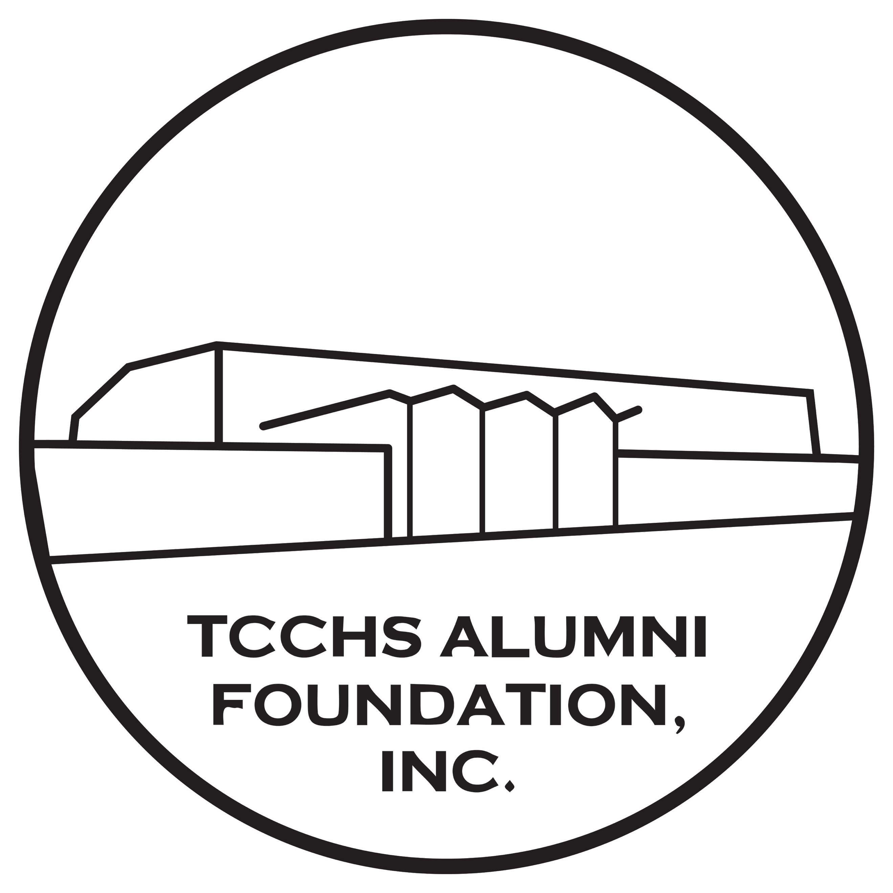

TCCHS Alumni FOUNDATION, INC. Newsletter
“Celebrating Our Past, Our Present, and Our Future”

https://tcchs-alumni.org
Volume 15, December 2023

TCCHS Alumni Association Announces Its Formation
of the Todd County Central High School Alumni Foundation, Inc.

In May of 2013, several TCCHS alumni who later became the first organizers of the TCCHS Alumni Association met and organized an entity working under the umbrella of a nonprofit foundation originally established by the Todd County Board of Education. Because of the success the alumni association has experienced in the past 10 years, officers and directors of the alumni association in recent months began an effort to form their own nonprofit foundation. That effort culminated in recent days with the Kentucky Secretary of State’s Office stamping its approval on the Articles of Incorporation and Bylaws of the new Foundation, one called the Todd County Central High School Alumni Foundation, Inc. Those documents were filed on July 12, 2023 with the Kentucky Secretary of State’s Office and on July 17, 2023 at the office of Cindy O’Bryan, Todd County’s County Clerk, thus finalizing the new Foundation becoming legally incorporated. IRS paperwork is currently underway, and that process will more than likely entail several months for completion.

Anna Jo Parmley, TCCHS Class of 1966 and the newly elected president of the TCCHS Alumni Foundation / Association, messaged, “We are so excited about this new phase in the operation of the Foundation. We are also so very blessed we have received the support of several local individuals and TCCHS alumni as the legal documents were prepared and sent to the Secretary of State’s Office for filing.” Those individuals include alumni Tyler Gill of ELPO Law in Elkton, and Jason Petrie, State Representative, who delivered the articles / bylaws to Secretary of State Michael Adams’s office in Frankfort. Alumni officers also met in recent days with Earl Calhoun of Calhoun & Company, PLLC in Hopkinsville who will complete and oversee the IRS portion of the documentation. Linda Fritz, vice-president, emailed, “I have felt so blessed to be a part of such a wonderful organization as the TCCHS Alumni Association in the past years. However, today I am elated this organization has now met the legal requirements to become a Foundation!”

Charlotte Morrow, a director-at-large, added, “We have been blessed in recent years with so many interested in providing scholarships for the graduates of TCCHS, and we anticipate we will have even more interest as the new Foundation moves forward.” At their regular meeting this past week, the officers / directors emphasized the almost 50 lifetime members of the association will be “grandfathered” into the new Foundation. Those lifetime memberships are $200 with yearly memberships $10. The officers / directors also voted at the July meeting to have a booth at HarvestFest on Saturday, September 23. That will allow the Foundation to sell its alumni items including commemorative TCCHS coins, blank cards featuring schools and past schools of the county as well as the Elkton mural on East Main Street, prints of TCCHS by Kim Daniel Rager, silicone phone wallets, bricks from the former Todd County High School / Elkton Elementary, silicone bands, and mugs also featuring some of the former schools of Todd County. Memberships, either as alumni or friends of the Association / Foundation, will also be available.

Ms. Parmley pointed out the emphasis of the alumni association in past years has been centered on scholarships with the 23 scholarship applicants this past May receiving a total of $52,000. She also added, “Because this year is the 60th year of TCCHS, the scholarship committee chose to provide each of the 23 applicants with a $1,000 scholarship honoring TCCHS’s first year.” Most who know about TCCHS’s history will recall TCCHS opened its doors in the fall of 1963. Since its first offering scholarships in 2014, the Alumni Association has provided $183,850 in scholarships to TCCHS graduates. Ms. Parmley also commented, “To raise the money for the two scholarships the Alumni Association / Foundation provides, we rely upon the payment of membership dues and the sale of our alumni items.” She also stressed the Foundation is open to everyone, not just TC alumni. One of the most faithful members is Robert Neeble, a native of Cadiz who attends with his wife, Sue Neeble, a 1969 TCCHS graduate. This month another attendee at the meeting was Dana Orr, a native of Christian County who has made her home in Todd County since marrying her husband, George Orr.

Another highlight for the new Foundation in recent days was the launching of the TCCHS Alumni Foundation, Inc.’s website. That event, one occurring on Thursday, July 20, was an exciting one as the Foundation continues its promotion of the organization utilizing the Internet. CLW, designer of the website, posted on Facebook, “Please note this is not a BMW website; this is one designed by an owner of a Prius!” Utilizing WordPress, the website (https://tcchs-alumni.org) provides facts about the organization, officers / directors, memberships, and related information. If you are interested in becoming active with the Foundation, meetings occur the third Tuesday of each month (except December) at 4:00 PM. The Foundation expresses its thanks to Elkton Baptist Church for allowing us to meet at the Christian Fellowship Center at 207 East Main Street. Please note this is the former “Bell Clinic” since several who attended this past July meeting were not quite sure of the location.

Officers / Directors elected for 2023-2024 at the July meeting include Anna Jo Parmley, President (Class of 1966); Linda Fritz, Vice-president (Class of 1966); Joyce Darby, Treasurer (Class of 1972); and Carolyn Wells, Secretary (Class of 1968). Directors-at-large include Jeremy Long (Class of 1998), Charlotte Morrow (Class of 1968), and Sue Neeble (Class of 1969). Two non-voting directors-at-large include Lee Quarles (TCCHS principal) and Kimberly Davis (TCMS). If you have questions, feel free to send an email to tcchsaa@gmail.com. Donations to the Foundation are always welcome. The mailing address for the Association / Foundation is P.O. Box 611, Elkton, KY 42220. We encourage you as well to “like” us on Facebook; we changed the name of our page to reflect our new status as the Todd County Central High School Alumni Foundation, Inc.

~ Article by Carolyn L. Wells
July 22, 2023

Thank You, Brittney Addison

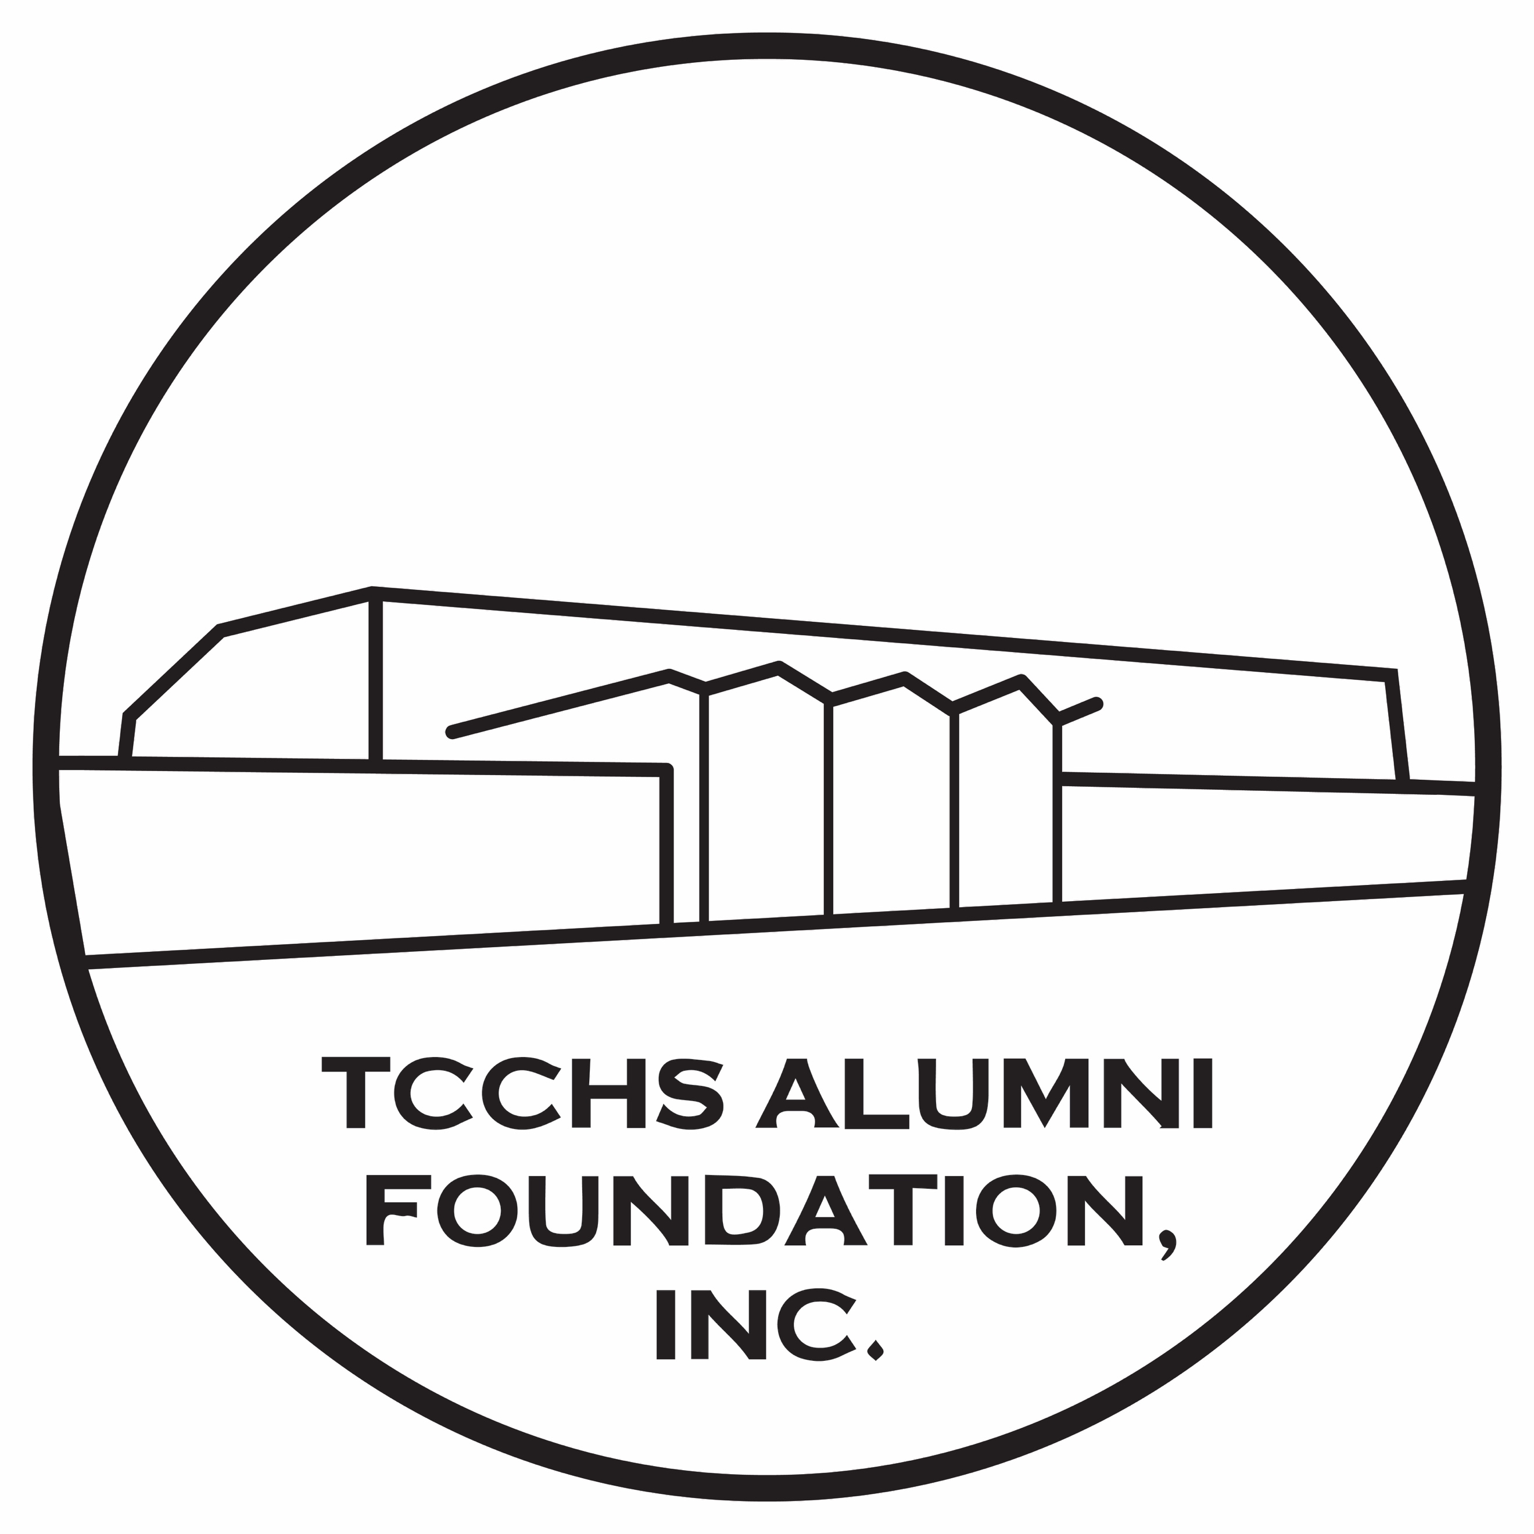

We appreciate Brittney Addison, TCCHS Class of 2006, designing a circular logo to accompany our newly formed TCCHS Alumni Foundation, Inc. Brittney, who works at Elkton Bank & Trust Company in Elkton, has a bachelor’s degree in fine arts from Austin Peay State University! Brittney, we appreciate so much your willingness to use your myriad talents to assist us!

TCCHS Alumni Association Awards $52,000 in Scholarships to TCCHS CLASS of 2023!
Mrs. Joyce Darby, the TCCHS Alumni Association’s treasurer who is also a retired CPA, shared in recent days she hopes the generosity shown this year to the TCCHS Class of 2023 will encourage more individuals, businesses, and alumni to sponsor scholarships in the future. Her remarks follow this year’s TCCHS Class of 2023 receiving $52,000 in scholarship monies on Tuesday evening, May 9, at the annual TCCHS Awards Program held in the TCCHS auditorium. That figure, which included 23 students receiving 29 different scholarships, reflects the love Todd Countians and those with Todd County and/or TCCHS roots have for the next generation of TCCHS graduates.
That $52,000 figure also reflects an increase of $25,150 from the scholarships provided in 2022. Since its formation in 2013 and its first awarding scholarships to the TCCHS Class of 2014, the TCCHS Alumni Association has awarded in a ten-year period approximately $187,000 in scholarships to TCCHS graduates. Mr. Lee Quarles, principal of TCCHS who worked previously in the Clarksville - Montgomery County School System, remarked recently he was amazed at the total amount of monies the association continues to provide to TC grads. Anna Jo Parmley, a director of the association and a 1966 graduate of TCCHS, shared, “It is so rewarding the association has the support of so many individuals and groups who want to ‘give back’ to their alma mater and their community.”
In announcing the scholarships at the Awards Program, Carolyn Wells, secretary for the association, explained this year’s scholarships reflected two new businesses who willingly embraced the association and its efforts to assist the seniors of TCCHS. One of those business owners, Ms. Jo Ann Coblentz of “Jo Ann’s Country Flowers” of the Guthrie area, expressed her desires to assist a student entering into an agriculture-related area. Ms. Coblentz’s scholarship in the amount of $3000 also reflects the largest monetary figure for a scholarship during the association’s 10 years. Obviously, someone who works in an agriculture area realizes the need for the next generation to learn the skills required to add to the work force.
The other new sponsor this year is Myles McIntosh of “M Printing” of the Springfield area. Myles, a 2004 graduate of TCCHS, reached out in recent weeks with his desire to support a student pursuing a degree in a technical area. This year’s scholarships also saw Bob and Sandy Carver increase the Gary Strader Memorial Technical Scholarship from $500 to $1000. That scholarship is in memory of Sandy’s first husband who died in a farming accident shortly after their high school graduation. Because of the generosity of Todd County supporters, the Directors/Officers of the association were also able to provide each of the 23 applicants a $1000 TCCHS Alumni Association’s Scholarship Honoring TCCHS’s 60th Year. As many are aware, TCCHS first opened its doors in the fall of 1963, and the officer/directors wanted to honor TCCHS’s heritage through these additional scholarships.
Other sponsors this year include ones who in previous years have also reached out to the association offering to sponsor scholarships to ‘ease’ the financial burden graduates and their families experience as graduates bridge their lives to the next chapter. Charlotte Morrow, another director of the association and a retired educator as well, commented, “We have been so blessed to have so many willing to write checks and support our TCCHS graduates yearly.” Adding she understands times are difficult for many, she also expressed her gratitude to those who faithfully provide the monies needed to maintain the scholarships each year. Ms. Parmley, who worked for many years as a social worker and with the Todd County School System in several roles, also emphasized the need for those receiving scholarships to send ‘thank you’ notes to those sponsors who so willingly donate the scholarship monies.
Scholarship Recipients and Sponsors
Jo Ann’s Country Flowers’ Agricultural-related Scholarship
Recipient – Emma Danielle McGhee
Scholarship Amount – $3000
Sponsor – Ms. Jo Ann Coblentz of Guthrie
Myles McIntosh Technical Scholarship
Recipient – Latanya Maxine Barrozo Galima
Scholarship Amount – $1000
Sponsor – Myles McIntosh of “M Printing” of Springfield, TN
Alton and Bessie Greenfield Memorial Academic Scholarship
Recipient – Hannah Oliver
Scholarship Amount – $500
Sponsor – Mrs. Ruth Elliot of Hopkinsville
Howard Ray Stokes Memorial Academic Scholarship
Recipient – Logan Neil Cherry
Scholarship Amount – $500
Sponsors – The Late Dolly Stokes Rawlins and Mrs. Linda Stokes Fritz
Gary Strader Memorial Technical/Trade Scholarship
Recipient – Madison Frogue
Scholarship Amount – $1000
Sponsors – Mr. and Mrs. Bob Carver
Jeffery Wayne Farmer Memorial Scholarship
Recipient – Latanya Maxine Barrozo Galima
Scholarship Amount – $500
Sponsor – Mr. and Mrs. Wayne Farmer
TCCHS Alumni Association Academic and Technical Scholarships
Recipients – Jarrett Logan Stamps and Isabella R. Dossett
Scholarship Amount – $750 Each
Sponsor – TCCHS Alumni Association
TCCHS Alumni Association Business or Accounting Scholarship
Recipient – Jonah Alexander Rager
Scholarship Amount – $1000
Sponsor – Anonymous
Carolyn L. Wells Academic and Leadership Scholarships
Recipients – Jonah Alexander Rager, Alexis Frogue, and Lucy Ellen Chester
Scholarship Amount – $1000 Each
Sponsor – Carolyn L. Wells
Carolyn Wells Writing Scholarship
Recipient – Hailie Perry
Scholarship Amount – $500
Sponsors – Mrs. Lana Kim White Austin and Two Friends of Carolyn L. Wells
TCCHS Alumni Association Memorial Academic or Technical Scholarship
Recipient – Chandler Dare Wood
Scholarship Amount – $2000
Sponsor – Anonymous
Tom and Rowena Everett Memorial Academic Scholarship
Recipients – Emily Oden
Scholarship Amount – $2000
Sponsors – The Late Tom and Rowena Everett
Sharon Patterson Shemwell Memorial Scholarship
Recipient – Emma Danielle McGhee
Scholarship Amount – $500
Sponsor – Mrs. Darlene Groves of “Something Special”
Bruce and Linda Marklin Scholarship
Recipient – Jenna Kaitlyn Dossett
Scholarship Amount – $1000
Sponsors – Bruce and Linda Marklin
Randall and Nancy Powell Healthcare Scholarships
Recipients – Hannah Oliver, Alexis Frogue, and Leah Rose Harris
Scholarship Amounts – $1000 Each
Sponsors – Mr. and Mrs. Randall Powell
Todd County Chamber of Commerce Academic or Technical Scholarship
Recipient – Jonah Alexander Rager
Scholarship Amount – $1000
Sponsor – Todd County Chamber of Commerce
“That Guy Who Fixes Stuff” Scholarship
Recipient – Lucy Ellen Chester
Scholarship Amount – $1000
Sponsor – Terry Greene of “That Guy Who Fixes Stuff”
Andrew “Cheston” Miller Memorial Scholarship
Recipient – Logan Neil Cherry
Scholarship Amount – $1000
Sponsors – Anonymous and Allen and Janie Franks
Novelis – Guthrie Academic or Technical Scholarships
Recipients – Hailie Perry, Addileigh Reagan Wofford, Lucy Ellen Chester, Madison Frogue, and Ashton Davis Murrey
Scholarship Amount – $1000 Each
Sponsor – Novelis – Guthrie
TCCHS Alumni Association’s Scholarship Honoring TCCHS’s 60th Year
Recipients – Abigail Roxanna Blake, Addileigh Reagan Wofford, Alexis Frogue,
Ashton David Murrey, Chandler Dare Wood, Emily Oden, Emma Danielle McGhee,
Hailie Perry, Hannah Oliver, Isabella R. Dossett, James Evan Thomas,
Jarrett Logan Stamps, Jenna Kaitlyn Dossett, Jonah Alexander Rager,
Latanya Maxine Barrozo Galima, Leah Rose Harris, Logan Neil Cherry,
Lourdes Y. Anastacio Baltazar, Lucy Ellen Chester, Macayle Layne Ayersman,
Madison Frogue, Madison Grace Henderson, and Neyda Cajija DeLaCruz
Scholarship Amount – $1000 Each
Sponsor – TCCHS Alumni Association
~ Article by Carolyn L. Wells
May 18, 2023

we Thank you, Scholarship sponsors!

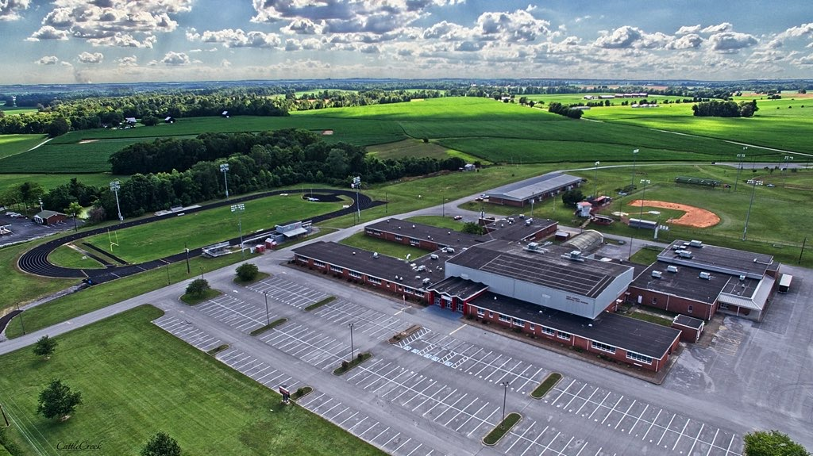
Photo by Tony Hurt

tcchs alumni foundation, inc. memberships sought

We invite all interested individuals to become involved in the TCCHS Alumni Association / Foundation either as a graduate of TCCHS or as a friend of our organization. Memberships are either $10.00 yearly or $200.00 lifetime. A yearly membership can be contributed at any point during a calendar year. However, to make renewals easier, we suggest renewing during your birthday month. Obviously, lifetime memberships can also be made at any time someone chooses. Please note those nearly 50 alumni who joined the TCCHS Alumni Association in years past will have their lifetime memberships “grandfathered” into the TCCHS Alumni Foundation, Inc. All memberships help fund our scholarship efforts and other items we purchase and sell to generate monies for our scholarship efforts. Checks can be made out to TCCHS Alumni Foundation. Our mailing address is P.O. Box 611, Elkton, KY 42220. Please know we appreciate the generous support we have received in past years! We also know our future is extremely promising as well!

WEKT Partners with TCCHS Alumni Foundation, Inc.

The TCCHS Alumni Foundation, Inc. is partnering with WEKT to spotlight alumni of TCCHS to celebrate the first 60 years of TCCHS’s existence. As most know, Todd Central first opened its doors in the fall of 1963, and the Foundation and WEKT want to provide ‘snippets’ of facts about those who have exited the doors of TCCHS. With a span of 60 years, a cautious estimate of approximately 7500 or more students have become graduates of TCCHS. As we also know, many other students have attended TCCHS for less than four years, and we welcome responses from those students as well.

If someone had time to track down all the many students who have attended TCCHS during those six decades, the result would be mind-boggling. I just recently heard of a young lady who attended TC for at least a year before she moved to Massachusetts with her mother. Sadly, this young lady, Chandra Lekha Sriram, passed away in September of 2018. Born in Texas in 1971, Chandra earned early admission to Bard College at Simon’s Rock in Great Barrington, Massachusetts, receiving her associate’s degree in 1989. Later, she obtained both a bachelor’s in political science and a master’s in international relations from the University of Chicago simultaneously in 1991. An author of several books, she was also awarded a doctorate in law by the University of California-Berkeley in 1994 and a Ph.D. in Politics by Princeton University in 2000. More about Chandra’s amazing life can be found at https://lachandra.org. Those few facts alone reveal the caliber of this young lady.

Obviously, without the assistance of alumni of TCCHS and students who have attended TCCHS, the Foundation’s partnership with WEKT will not be a successful effort. A simple form to complete is available on the TCCHS Alumni Foundation’s website at https://tcchs-alumni.org/news-of-interest/. The form itself has questions that can be completed with little investment of time. We are also proud to announce the first alumna of TCCHS to complete the form is Libby Sims Lancaster, a 1974 graduate of TCCHS. Many older Todd Countians will recall the late Mr. Glen Sims, and Libby, the oldest of the four Sims sisters, graciously completed the form a few days ago. Forms can be downloaded, and answers can be sent to the Foundation’s email address at tcchsaa@gmail.com.

Libby, one known for her extraordinary singing voice, attended Christian County Area Vocational School and HCC. For 31 years full time and six and a half years parttime, Libby served as a Certified Water Treatment Plant Operator/Water Quality Specialist. She noted on the questionnaire, “I value the solid grounding in all areas I received from those four years at TCCHS. Even without a college degree, I was able to function in a technically demanding field.” When asked what advice she would give to TCCHS’s students, she replied, “Take the harder courses. Stretch yourself.” In commenting on her advice for today’s educators, she admonishes them to teach students “to think outside the box and to think critically.” Adding she still knows the “Hallelujah” chorus” almost by heart, she also shared the memory she treasured the most was being able to sing excerpts from Handel’s Messiah in Mr. George Mills’ class. Libby and her husband have two children and make their home in the Pembroke area.
WEKT has plans to share these snippets of facts about those who have walked the halls of TCCHS during those six decades! Both WEKT and the Foundation are eager to learn more about the many students who have exited TCCHS with quite a few of those students living not only across our country but across the world as well. Please lend us a ‘helping hand’ to make this partnership a strong one! Follow this link to see all alumni that have been placed online –
https://www.wektradio.com/category/tcchs-alumni-spotlights/.

Article by Carolyn L. Wells
September 24, 2023

tcchs alumni foundation, inc.’s 2023 — 2024 Officers/Directors

Our officers/directors for 2023-2024 were elected at the July 18, 2023 meeting of the alumni association.
President … Anna Jo Moore Parmley (Class of 1966)
Vice-President … Linda Stokes Fritz (Class of 1966)
Secretary … Carolyn L. Wells (Class of 1968)
Treasurer … Joyce Wright Darby (Class of 1972)
Director-at-Large … Charlotte L. Morrow (Class of 1968)
Director-at-Large … Jeremy Long (Class of 1998)
Director-at-Large … Sue Frederick Neeble (Class of 1969)
Non-voting Director-at-Large … Lee Quarles (TCCHS
Principal )
Non-voting Director-at-Large … Kimberly Davis (TCMS Principal)
(The two principals are members of the Association / Foundation because of their roles as principals with the TCMS principal serving as a bridge to connect to TCCHS.)

memberships in the tcchs alumni foundation, inc. are $10.00 yearly or $200.00 for a lifetime membership!

“Second Annual Music at the Milliken: A Steinway Serenade” An event of Saturday, June 24, 2023

The website of the Milliken Memorial Community House has on it these words – The “Milliken Memorial Community House was founded from the loving heart of Mary Louise Milliken Childs in 1928. Her desire to create a gathering place with the purpose of bettering the community of her childhood was realized in the building of this special charitable project that stands today as a testament to her benevolence.” Saturday evening, June 24, 2023, saw five members of our community share their extraordinary talents as they performed at the “Second Annual Music at the Milliken: A Steinway Serenade.” Those five musical artists, four pianists and one vocalist, included vocalist Mrs. Amanda Brunt of Elkton and pianists, Dr. Mark Campbell of Trenton, Ms. Emilie Gill of Elkton, Ms. Dawn Sharp of Elkton, and Mrs. Judy Wilson of Kirkmansville.

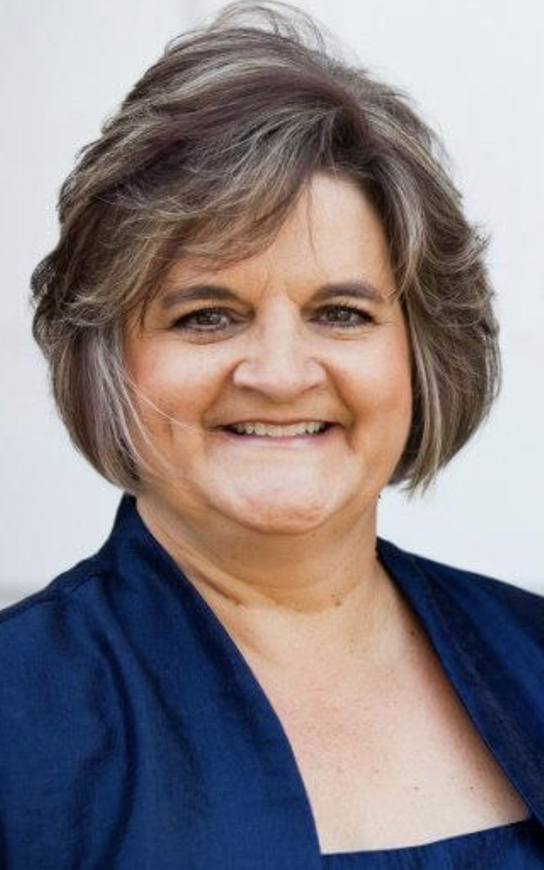

Amanda Sweeney Brunt Dawn Dickinson Sharp

The event, a summer fundraiser for the Milliken, saw a gathering of nearly 50 adults and a few of the younger generation experience an evening of musical excellence. Those present enjoyed the sounds of the Steinway, a treasured baby grand piano on loan to the Milliken from the Green River Academy. Those not familiar with the Steinway may not realize it has 233 strings that create a much richer musical sound than other pianos. That “richer sound” led to the evening’s performance being dedicated to the Todd County Health Department and Mrs. Jen Harris, Director. In his remarks prior to the concert, Tyler Gill, well-known lawyer and the father of Ms. Emilie Gill, stated both Mrs. Harris and the Todd County Health Department worked tirelessly during the pandemic and in recent years to “keep our community safe and healthy.” Mrs. Sylvia Gill, mother of Emilie Gill, added, “I appreciate so much the opportunity to attend an event that showcases so much of Todd County’s talent and contributes to the preservation of our Community House.”

Those in attendance were serenaded with pieces including those of W.A. Mozart, Franz Schubert, Georges Bizet, Ludwig van Beethoven, Albert Ellmenreich, Giacomo Puccini, and Andrew Lloyd Webber. Mrs. Brunt included in her selection of songs “I Know Who Holds Tomorrow” and “Somewhere Over the Rainbow.” She also shared prior to her singing of “I Know Who Holds Tomorrow” that as a child she was worried about asteroids falling down upon her. Reassured by her mother she could do nothing about it, she soon realized her fears were unfounded as she stated, “Today I know I am not in charge, and I also know Who is.” Frank Walton, a well-known song leader and elder at the Church of Christ at Trenton Crossing in Clarksville, messaged, “What an enjoyable evening at the Milliken. My wife and I recognized several piano compositions consisting of classical, contemporary, and religious pieces expertly played on the baby grand.” He also shared it was a special treat to hear Amanda sing John Denver’s “For Baby (for Bobby),” a song he has performed at many weddings.

Commenting she was not a professional pianist, the youngest performer present, Ms. Gill, messaged, “It was such a pleasure to collaborate with other passionate and talented musicians to share some of our favorite pieces of music. I always strive to keep improving, and it was wonderful to be able to share what I’ve been practicing over the last year with other music lovers.” Stating she was humbled to be asked to perform, Mrs. Wilson voiced in pen what so many voiced about Ms. Gill’s talents, “I love to watch her emotions and passion for the keyboard when she performs!”

Mrs. Brittany Prather, president of the Milliken’s Board of Directors, commented at the end of the evening’s performances, “The ‘Grand Old Lady’ would be so proud to have witnessed the performances of the five musicians tonight as well as the support of so many Todd Countians who opened up their checkbooks to give back to such a beloved community treasure.” She added, “The heart of the Milliken revolves around our community, and tonight’s performance highlights again the beauty of the Milliken and the impact it has on Todd County.” She also added, “I can only imagine those responsible for the gifting of this community house did so with an event such as this in mind.” On the Milliken website we discover it has over 380 plus donor members, 24 social events yearly, 93 years of existence, and 14,000 people impacted annually by events hosted there. Those who would like to support the efforts of the Milliken can send tax-exempt donations to the Milliken Memorial Community House, P.O. Box 114, Elkton, KY 42220.

~ Article by Carolyn L. Wells
July 1, 2023

David Cunningham, a 2000 TCCHS Alumnus, Excels in His Profession

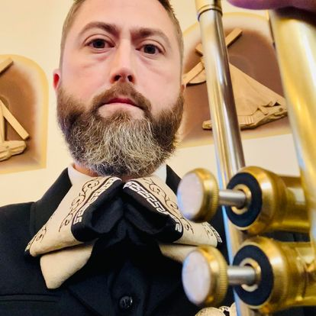
When we take a few minutes and ponder almost 60 years of alumni who have exited the doors of TCCHS, we can all share success stories of graduates who have pursued their chosen paths in life and excelled in them. All of us also realize how much music is a core part of so many people’s lives with one South Korean singer named Psy reminding us, “The world's most famous and popular language is music.” One of TCCHS’s early 21st Century graduates, one who excelled in music while at TCCHS and who now excels in his adult life, recently received a recognition for his students’ extraordinary talent. That young man, David Cunningham, was a member of the TCCHS Class of 2000. David currently makes his home in Kansas City, Missouri, and teaches at Paseo Academy of Fine and Performing Arts, a high school part of the Kansas City Public School System.
David Cunningham

The son of Crystallie McFerrin of Todd County and the grandson of the late James and Eleanor Anderson, David just completed his 18th year as an educator. In talking about his grandparents who owned a farm on Highway 181, he messaged, “They were my primary caregivers, and I owe everything to them.” He clarified they taught him the value of hard work even though they were older and tired. He added, “They did everything in their power to support me as a musician. They took me to practices, concerts, and festivals, always assuring I had the best resources available to be successful.” A graduate of Western Kentucky University and the University of Missouri with both bachelor’s and master’s degrees in music education, David is currently Director of Bands and Jazz Studies at Paseo Academy of Fine and Performing Arts, in Kansas City, Missouri. Just recently David became the Chairman of the Department of Performing Arts.

The most current recognition David’s students received was being named the National Heritage Instrumental Ensemble Sweepstakes Winner. That recognition equates to David’s students performing before a group of nationally acclaimed musicians, receiving feedback from those musicians, and being encouraged to reach new heights in the future. The competition, which was held in Chicago in recent months, saw David’s students win the highest award that can be won. He shared, “We competed against 21 other instrumental music groups from all over the country, including two international groups from Ecuador and Mexico.” He also explained when he inherited the Paseo program several years ago, the program had dwindled to about 15 students, thus creating a huge void David had to rebuild.

When asked what excites him about music and his current job, David messaged, “Paseo has a long history of producing some of the finest artists. Students must audition to be accepted, so the students who attend already have displayed tremendous talent and the drive to become professional artists.” David had 80 students daily in the band program this past school year, and he anticipates the number will probably grow closer to 100 next year. He also added he hopes his students will be thankful for all the experiences the Paseo band program provides including its competitions, its trips, and its celebrations.

In reflecting on his background in music education in Todd County, David stated, “Our director at TCCHS, Chris Heffner, showed me that being a music teacher can be a very fulfilling job if you put your whole heart in it.” He also added kudos to the late Fred Borders at TCCHS and the late Dick Weaver at TCMS for inspiring him in music. Reminiscing about his earlier years at WKU, David explained, “My trumpet professor at WKU, Dr. Marshall Scott, pushed me to be the best musician I could be. He also helped me reach a high level of musicianship and provided the knowledge I needed to be a professional musician.”

David’s family includes his wife Sandra, who is also a teacher, and their two children, Eleanora and Davey. The two young Cunningham children enjoy music and are already playing the piano. David added, “I have been so lucky to meet and network with many musicians since I have been in Kansas City. All my best friends are people I make music with on a regular basis.” He also added, “I would say being an educator can be one of the most rewarding jobs on the planet, if you work hard and give it everything you have.” He also reminds all educators always to remember how much you love your field and to share that love daily.

~ Article by Carolyn L. Wells
June 24, 2023

The Warren East High School Students of Cedrick Leavell, a 1999 TCCHS Alumnus, Receive Prestigious Music Award

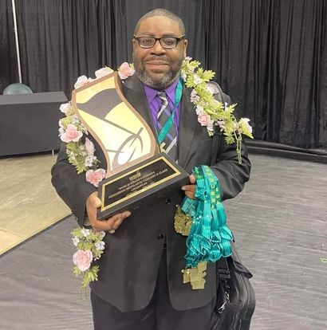
Sharing his TCCHS high school music teachers, Dr. Chris Heffner and the late Fred Borders, helped pave the way for his becoming a music educator, Cedrick Leavell, an alumnus of the TCCHS Class of 1999, just completed his 18th year as a music educator. A fall 2003 graduate of Western Kentucky University with a bachelor’s degree in music education, Cedrick is the band director at Warren East Middle School in Bowling Green, Kentucky. In 2012, Cedrick earned his master’s degree in music education, and this past year he taught approximately 200 students on a daily basis in the Warren County Public School System. Cedrick is the son of Lawrence and Beverly Carter of Todd County and makes his home in Bowling Green.

Cedrick shared when asked why he pursued education that his family, particularly his uncle Ventrell Leavell, a percussionist, inspired him. Cedrick clarified, however, his entire family had a role in his love for both music and education. When questioned about what excites him regarding music and his current job, Cedrick messaged, “The fact that I get to share my passion of music with the students I work with every day keeps me excited. I have the privilege of cultivating a love for music in these students.” Like so many educators, he also remarked, “It’s rather cool to see that love of music develop over time.” Interestingly, Cedrick’s classroom this past year was described as “The classroom most like a family with his students becoming close-knit throughout the year.”
Cedrick Leavell

This past school year, Cedrick’s percussion ensemble was named the 2023 WGI Scholastic Concert World Champions and Gold Medalists, a first for Warren East. The WGI, which stands for Winter Guard International, is the world’s premier organization that provides competitions in percussion, indoor color guard, and winds. With a history of over 45 years, the event this past April saw 40,000 participants at the regional level and more than 12,000 at the world championship event at the University of Dayton. The event itself is a prestigious one showcasing the many talents of high school students involved in music. Cedrick explained, “Warren East High competed in the Percussion Scholastic Concert A Class and was named the Atlanta Regional, Southeastern Color Guard, and WGI World Champions in the Class A Division.”

In an article from the Bowling Green Daily News, Cedrick explained his percussion group of 13 students was the “‘most hyper-energetic group I’ve ever met,’” adding if they were ever nervous, he could not tell it. Cedrick also explained that oftentimes the shows presented at the WGI are often dark in nature, and his students’ and his show, one called “Love Goes Right,” revolves around a couple’s love story from their first meeting through their walk down the aisle. A student in the ensemble also pointed out their group can easily be spotted since their outfits are all colorful in nature, a tribute to their vibrant and energetic personalities.

In talking about his family, Cedrick remarked, “My musical family is my foundation. In every phase of life and throughout my career, they have been more than encouraging, always lifting me up and being supportive.” He also shared he thought perhaps his family and friends were even more excited about his accomplishments than he is. Like so many young adults making their marks in the world, Cedrick emphasized, “It's wonderful to have such a superb support circle.”

When asked what he would say to someone considering music education as a career, Cedrick replied, “It is a very rewarding career if you really care about the kids and truly love music.” He also pointed out the job is a demanding one and can easily take a toll on someone if that person does not possess the qualities of loving youth and loving music. He added, “To share what you love with students makes it worth all the efforts.” Like so many other TCCHS grads, educators at Todd Central have often been the impetus leading alumni to explore their passions at the collegiate or technical area and make their marks on the next generation and the vocations they enter.

~ Article by Carolyn L. Wells
June 24, 2023

Todd County Retired Teachers’ Association Holds Summer Meeting/Get-together in Trenton

The Todd County Retired Teachers’ Association held a summer get-together on Tuesday, June 27th, at Traveler’s Lantern in Trenton. This event, one that was geared toward fellowship with retirees, also saw recent retirees invited to the meeting and luncheon. Retirees for the 2022-2023 school year include Dana Orr, special education consultant for the district; Wendy Henderson, media specialist at North Todd; and Melissa Roe, a visual arts teacher at TCCHS. Of those three retirees, Dana Orr was present for the meeting.

Mrs. Jo Ann Holder, president of the association, shared local dues for members for 2023-2024 remain at $10.00 with members able to pay those dues to Jean Odum, treasurer of the association. She also shared the local association won several awards during the past school year. One of those awards included a certificate of recognition for reaching the goals and objectives of the Kentucky Retired Teachers’ Association.

Another recognition, the “YES WE DID” award, was received by the local association for meeting or exceeding a membership goal of 75% for the past year. Carolyn Wells was also recognized for winning the Volunteer of the Year Award at the local level as well as at the Third District Level and the state level. The state level award is the Frank R. Hatfield Volunteer of the Year Award, one honoring a former Kentucky retiree who contributed much to his community and state. Members were also encouraged to “Adopt-a-Student” for the approaching new school year with that effort focused on providing clothing for students at all levels.

Jane Mallory, secretary of the association, announced her resignation, and Carolyn Wells accepted that position for the remaining term of Mrs. Mallory’s office. Mrs. Holder also shared letters would be sent in August regarding meeting dates and places for the 2023-2024 school year.

Those 18 members in attendance at the meeting included Sandra Wright, Charlotte Morrow, Jane Dyer, Donna Settle, Connie Wofford, Mildred Bellar, Carolyn Wells, Jane Martin, Jean Odum, Peg Coots, Peggy Oller, Keith Dickinson, Wanda Nichols, Judy Howle, Ruth Bland, Rita Dillingham, Jo Ann Holder, and Dana Orr.

~ Article by Carolyn L. Wells
July 7, 2023

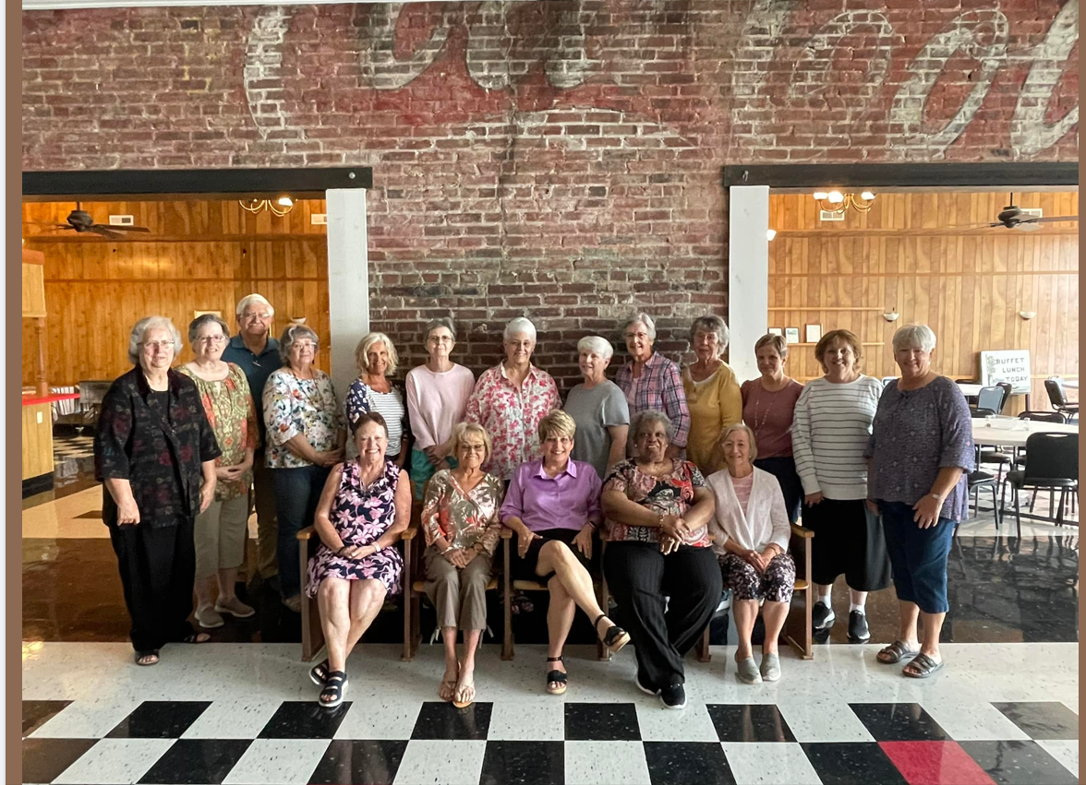

TCCHS graduates pictured include Wanda Law Nichols, Connie Bellar Wofford, Donna Morgan Nabb, Carolyn Wells, Ruth Lawson Bland, Jo Ann Dickinson Holder, Jean Roper Odum, and Charlotte Morrow. Also included are Mrs. Mildred Bellar, a former TCCHS science teacher. Another in attendance but not pictured was Jane Slack Martin.


Thank you, WEKT, for supporting the TCCHS Alumni Foundation

Lessons from the Life of
Stevie Anderson Powell


The late Nelson Mandela, the first president of South Africa, provided these thought-provoking words – “We can change the world and make it a better place. It is in our hands to make a difference.” Though Mandela lived on another continent, his words could very easily be applied to Stevie Anderson Powell, a Todd Countian who made many lasting imprints upon the lives of those he met during his 71 years of life. Emphasizing the words never and always, Rick Wells, a former co-worker of Stevie’s at Logan Aluminum, provided this description of Stevie – “He was never in a bad mood all the time we worked together. He was always a joy to be around and was eager to help tackle any project with his ‘can do’ attitude. You could always depend on Stevie to be there when you needed him.”

Autry Moore, a former preacher at Trinity General Baptist Church who is now a full-time evangelist who is also a guest on WNES Radio of Central City each Sunday, explained Proverbs 18:24 surfaced several times as he pondered his preparation for the funeral. That verse reminds us “A man that hath friends must show himself friendly: and there is a friend who sticks closer than a brother.” Mr. Moore shared those a part of Stevie’s life were embraced as though they were a part of his family – always with a cheerful and robust greeting, a gentle hand on the forearm, and a willingness to assist whenever a person was in need. He also added when Stevie prayed, he kneeled and “talked to the Lord like we would talk with each other.” Brother Moore’s comments certainly point out two valuable lessons for us all – we need to be individuals willing to assist others, and our daily demeanor needs to be one welcoming to those people who are in our lives.

In his eulogy, Randall Powell, a second cousin of Stevie’s and one who considered Stevie to be a surrogate big brother, shared several other lessons that can be gleaned through the life of Stevie and be applied to us. One of those lessons Randall mentioned was Stevie’s passion for life and for those a part of his life. Randall described Stevie as a “loving, honest, funny, and creative individual with a gentle soul.” He also clarified the cornerstones for Stevie’s life were his Bible and his relationship with God. He added, “Stevie focused on using his life wisely and with purpose.” He also noted Stevie’s passions in life placed emphasis first on God, then his family, and then others. Adding Stevie was a listener, Randall explained others who knew Stevie commented he was “the best, always making others feel good, and always making others smile when they looked at him.” Again, those qualities found in Stevie are ones we all would do well to adopt into our own lives, especially with emphasis on making God and others the focal points of our lives. Randall added, “Can you imagine what kind of world we would have if everyone took the time and energy to talk to you, to listen to you, and to love you the way Stevie did?”

As with all of us, examples of humor, mischief, and ingenuity also surfaced as Stevie was remembered as a man whose favorite tool was duct tape, a “tool” he used often to solve the routine problems of life. Randall also shared, as characteristic of many of the Powell family members, that “rigging” was a specialty with Stevie often using unexpected ways to solve problems in life. Barry Rager, a second cousin of Stevie, added another layer to Stevie’s work ethic with Barry explaining everyone else’s tobacco crops had to be in place prior to Stevie taking the time to plant his own. Ashley Groves, nephew of Stevie, remarked he frequently sought assistance from Stevie, with Stevie always providing solutions to problems with his abilities to maneuver equipment, tools, and creativity to resolve dilemmas faced. A former co-worker from Logan Aluminum, Richard Carpenter, commented he could always count on Stevie to provide advice to him as they raised their three children. He also shared a powerful lesson we can learn from Stevie’s example – “He didn't have to wear a bracelet to be reminded of what would Jesus do because he did it every day.”

As obvious from Rick Wells’ comments, Stevie implanted many seeds of love in the lives sprinkled throughout his 71 years. Those many visible seeds of love included Stevie’s love of God, his family, painting, flowers, quilting, farming, and assisting anyone who needed a helping hand. Randall closed with this anonymous quote, “‘It takes a smile to offer hope; it takes a moment to offer help; it takes a loving heart to lift the spirit. Blessed is the person who shares a smile, spares a moment, and offers joy.” Those who knew Stevie would undoubtedly state the anonymous quote so fittingly summarizes Stevie’s life and our need to be the provider of smiles, love, help, and joy in the lives of those around us.

~ Article by Carolyn L. Wells
June 17, 2023

Since 2014 the TCCHS Alumni Association has generated almost $187,000.00 in scholarship monies with the TCCHS Class of 2023 receiving $52,000.00! The association was first formed in 2013. The following year we provided our first alumni scholarships. the Class of 2024 will have scholarships totaling approximately $35,000.00 available to them.

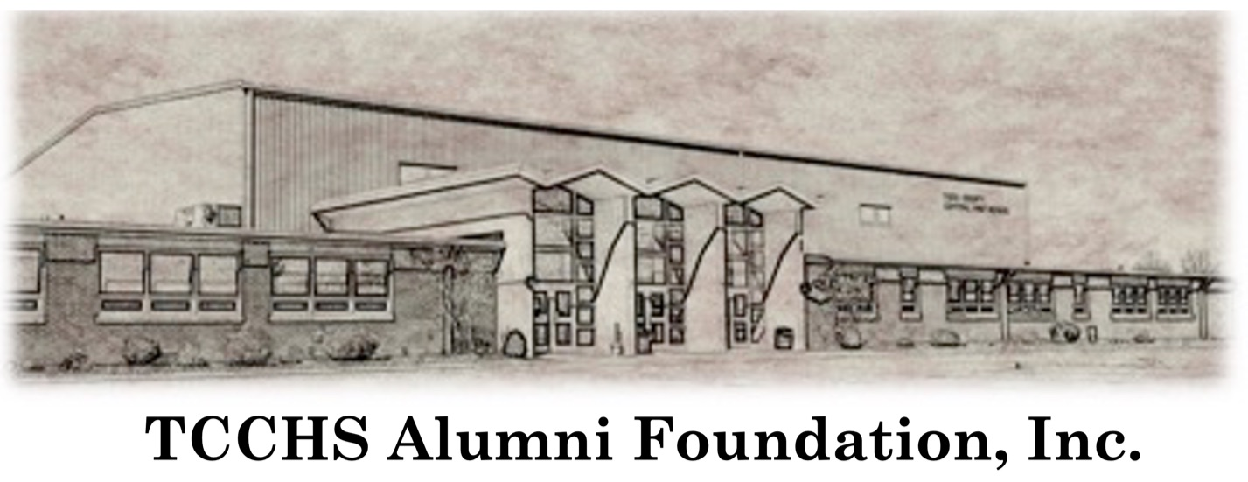

TCCHS first opened its doors in the fall of 1963. Since 1963, TCCHS has shaped the lives of graduates now spanning over 60 years.

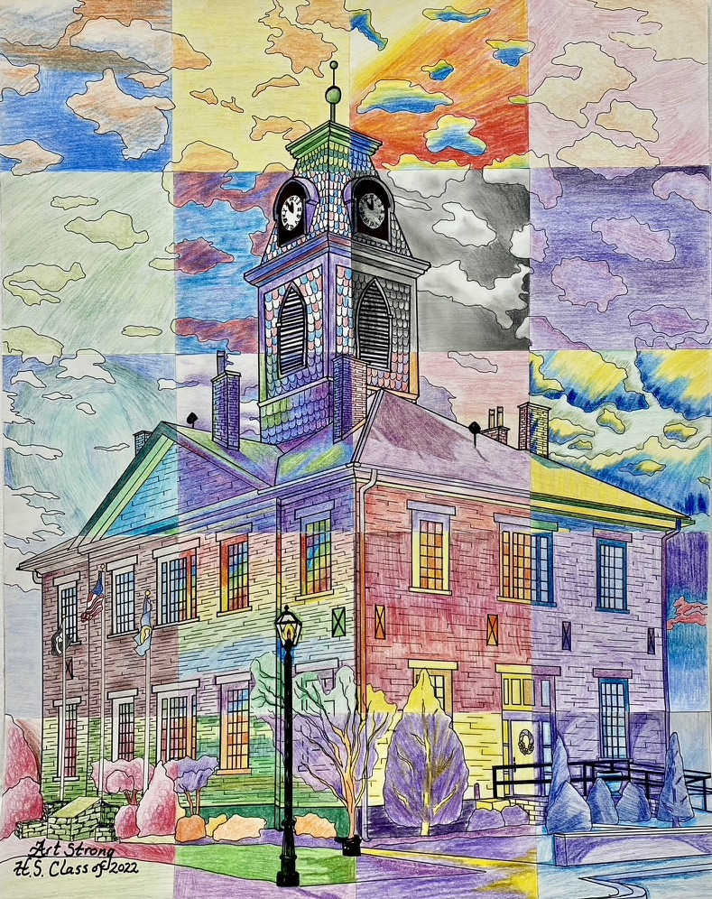

This unique piece of art was created through the efforts of Doris Martin Kelly, a TCCHS graduate, and members of the Art Strong Program under the direction of Samantha Morin Hightower, another TCCHS graduate.

Interesting Fact About alumni support of local organizations

2023-2024 Green River Academy Board of Trustees
In 2009, 174 years after the construction of the Green River Academy,
the charter GRA’s Board of Trustees was established to organize an effort to save
the Academy’s main building from destruction.
**Tiffany Groves (President)
*Camille Dillingham (Vice President)
*Matthew Colin Bailey
Tommy Hines
*Josh Mosby (Secretary)
**Lisa Petrie
**Alisa Gault Walsh
*Tonja West (Treasurer)
*Carolyn Wells

*TCCHS Alum
**Husband, Sibling, Children, and/or Relatives Attend/Attended Todd County Schools

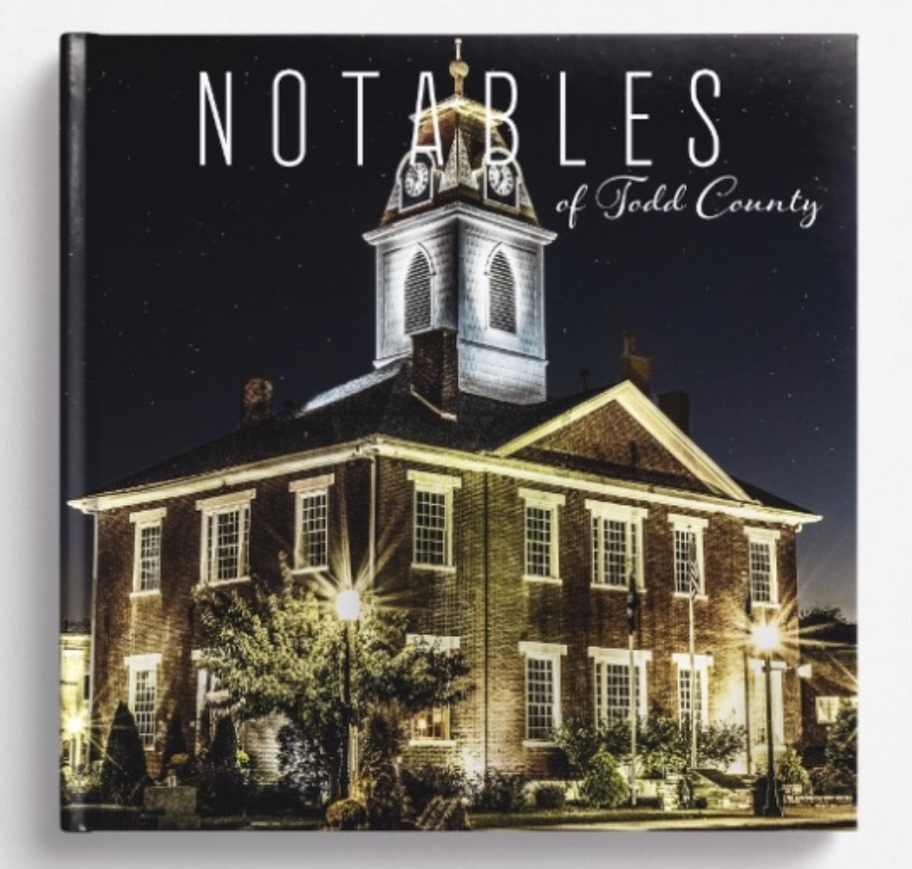

Notables of Todd County, a fundraiser for the Green River Academy includes art/pics from several TCCHS grads and current students. Those include Doris Kelly, Marla Gillespie, Lexie Johnson, Tony Hurt, Matt Bailey, Leah Harris, Beth Stewart, Robert Martin, Deana Power, Patsy Ann Wilkerson, Carolyn Potter, Tracy Robinson, Jo Ann Holder, and Carolyn Wells. Since its official launch on September 10, 2022, Notables has generated almost $31,000.00 in monies for the GRA. Copies are still available for $30.00 or for $35.00.

To generate $1500.00 for two local alumni scholarships of $750.00, the TCCHS Alumni Association must have at least 150 alumni or friends of TCCHS commit to a yearly membership of $10.00. Of course, having at least eight lifetime members paying $200.00 each will also provide that figure with an extra $100.00 for the association’s treasury. We need your support to generate those monies. We also have several items for sale locally!

TCCHS Commemorative Coins

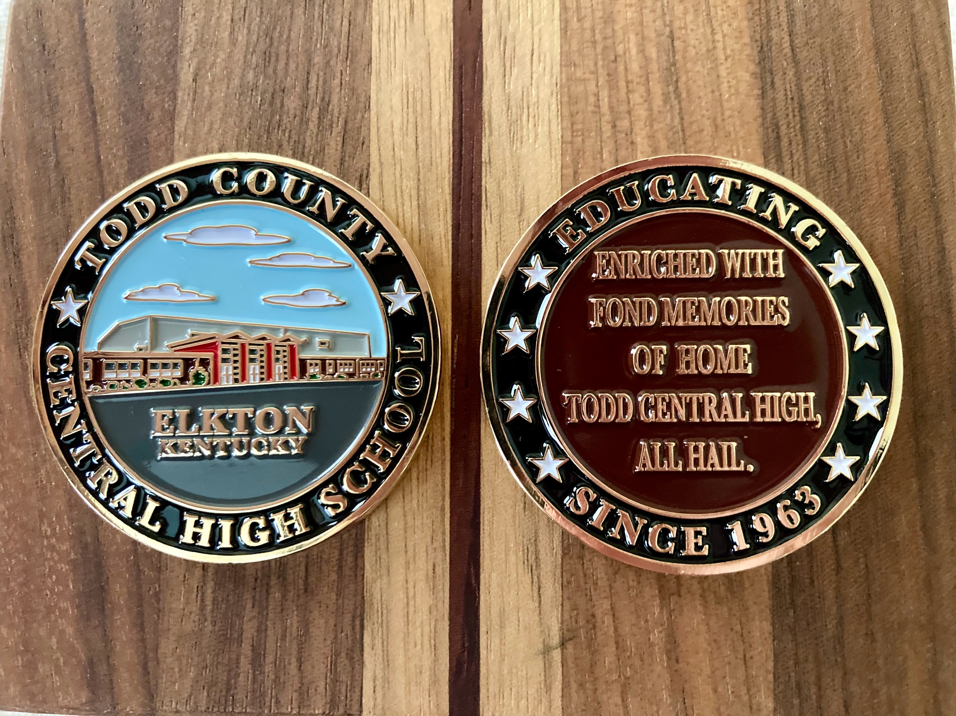

The TCCHS commemorative coins were donated to the association. The coins sell for $5.00 and make excellent gifts and keepsakes.

we hope your christmas 2023, new year’s, and 2024 will see many blessed occasions for you and your family, friends, and loved ones!

The TCCHS Alumni Foundation, Inc. offers yearly memberships for $10.00. We also have available lifetime memberships for $200.00. The memberships you provide support our efforts to fund two $750.00 scholarships the TCCHS Alumni Association offers. Your purchasing of the items we offer for sale also helps us reach that magic number of $1500.00 for our two scholarships. Please remember the yearly memberships run through december 31st and must be renewed annually. If you would like to make a donation to the scholarship effort, please send your donation to Joyce Darby, TCCHS Alumni Foundation Treasurer, P. O. Box 611, Elkton, KY 42220.

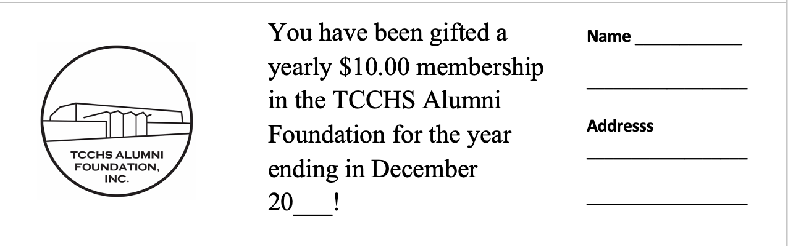

new item being offered!
this year we are offering gift yearly $10.00 memberships that can be used as stocking stuffers or gifts for any occasion. to purchase one, please send a check for $10.00 to the above address or see one of the alumni officers or directors to purchase from him or her.

tcchs alumni association offers several gifts for those seeking school-related items

The TCCHS Alumni Association has available blank post cards for the ‘feeder’ schools that fed into TCCHS in 1963. We also have added blank cards for TCMS, South Todd Elementary, and North Todd Elementary. One of our newest pack of cards features the ELKTON mural that adorns the side of “The Lucky Cowgirl,” formerly Campbell’s Drugs. A pack of five post cards with envelopes sells for $5.00.
We are also offering to the public post-card sized magnets featuring many of the former schools a part of Todd County’s history. Magnets with past schools of our county are $1.00 each. We still have bricks featuring the former Todd County High School or Elkton Elementary School that preceded Todd County Middle School and TCCHS. The bricks sell for $25.00 and make excellent keepsakes for those who have everything. We also have silicone phone wallets featuring the TC logo that sell $3.00 each or two for $5.00. We were gifted in recent years commemorative coins featuring a picture of TCCHS on the front as well as part of the alma mater on the back of the coin. The coins sell for $5.00 and make excellent gifts and keepsakes.

At this time the TCCHS Alumni Association has 55 ‘lifetime’ members! We appreciate so much the support of those who have chosen to devote $200.00 to their alma maters! We hope you will consider either joining as a ‘yearly’ member for $10.00 or a ‘lifetime’ member for $200.00. Your monies help us to fund our two $750.00 alumni scholarships. Our first ‘lifetime’ member was Myrtle Ann Brooks Mudge, a member of the TCCHS Class of 1965. Our latest lifetime member is Mr. Ashley Groves, a member of the TcCHS Class of 1989!

best wishes for a superb 2024!

We take this opportunity to wish each one of you and your family a blessed Christmas and holiday season 2023. we encourage any of you who have an interest in our work to attend our meetings and become more involved with the foundation. We meet monthly (except December), and our meetings typically last about an hour. currently we are meeting at the christian Fellowship Center of Elkton baptist church at 4:00 PM on the third tuesday of each month (except december). We also take this means to express our gratitude to the many alumni and friends of TCCHS who are willing to tackle the many projects we are involved with in our efforts to promote tcchs, its students, and its many graduates! Enjoy 2024 DAILY!

Recent Accomplishments of the foundation

- Determining a slate of officers/directors and directors-at-large for 2023-2024.
- Applying for and receiving state documentation making the TCCHS Alumni Foundation, Inc. a 501(c)(3) non-profit.
- Networking with WEKT to spotlight alumni of TCCHS during TCCHS’s 60th year celebration.
- Organizing and assisting with the 60th Year Reunion Homecoming Event at TCCHS on October 6, 2023.
- Encouraging more alumni and friends of the Foundation to become invested in the Foundation.
- Surpassing our yearly membership goal of having 100 members, now with 102 total members.
- Designing and launching a new website for the Foundation – https://tcchs-alumni.org.
- Adding links to the alumni foundation on several local websites.
- Promoting public relations via newspapers, emails, Facebook, alumni website, class reunions, and email newsletter.
- Maintaining and updating of an Excel spreadsheet with names and contact info on as many as possible of TCCHS’s graduating classes.
- Continuing the sale of past yearbooks digitized.
- Promoting of fund-raising activities, continued membership drive, and sale of various alumni items.
- Continuing sales of memorial bricks, commemorative coins, and blank cards for the former Todd County / Elkton High School, the feeder schools of TCCHS, North Todd, South Todd, and the ELKTON mural with proceeds earmarked for the scholarship effort.
- Awarding TCCHS Alumni Association Scholarships totaling $52,000 to members of the Class of 2023.

Thank You for Your Support of the TCCHS Alumni Foundation, Inc!

Our 102 “Lifetime” and “Yearly” Members, Bob and Sandy Carver; An Anonymous Donor of One $2000 Scholarship and An Anonymous Donor of a $1000 Scholarship; Wayne and Carolyn Miller Farmer; Randall and Nancy Powell; Mrs. Ruth Greenfield Elliott; Bill and Linda Stokes Fritz; the late Mr. and Mrs. T. D. Everett; Lana Kim White Austin and Two Friends of Carolyn Wells; Darlene Groves; Jeremy Long; Joyce Darby; Sue Neeble; Charlotte Morrow; Anna Jo Parmley, “Something Special” Owners and Staff; Mitzi Page, Owner of “Purple Daizi” and Her Staff; Paisalie Case, Owner of “Prim & Pupper,” Bruce and Linda Marklin; the Todd County Library and Staff; The Todd County Chamber of Commerce; Novelis – Guthrie; Jo Ann Coblentz and Ann’s Country Gardens; Charlotte and Bart Myers; Terry Greene and “That Guy Who Fixes Stuff;” Myles McIntosh; Ginger Taylor Simons; Marla Herrell Gillespie; Dana Grace Orr; Elkton Baptist Church; Tyler Gill and ELPO Law; and Susan Cumbee of Quality Office Products.

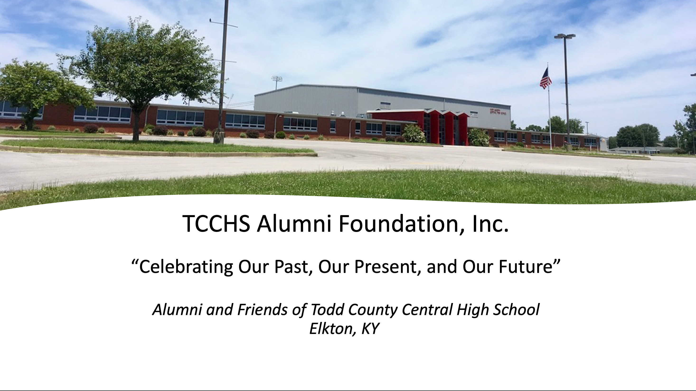

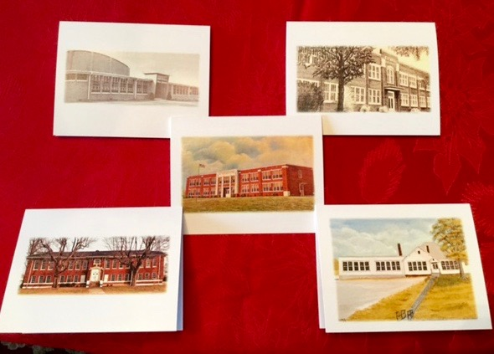

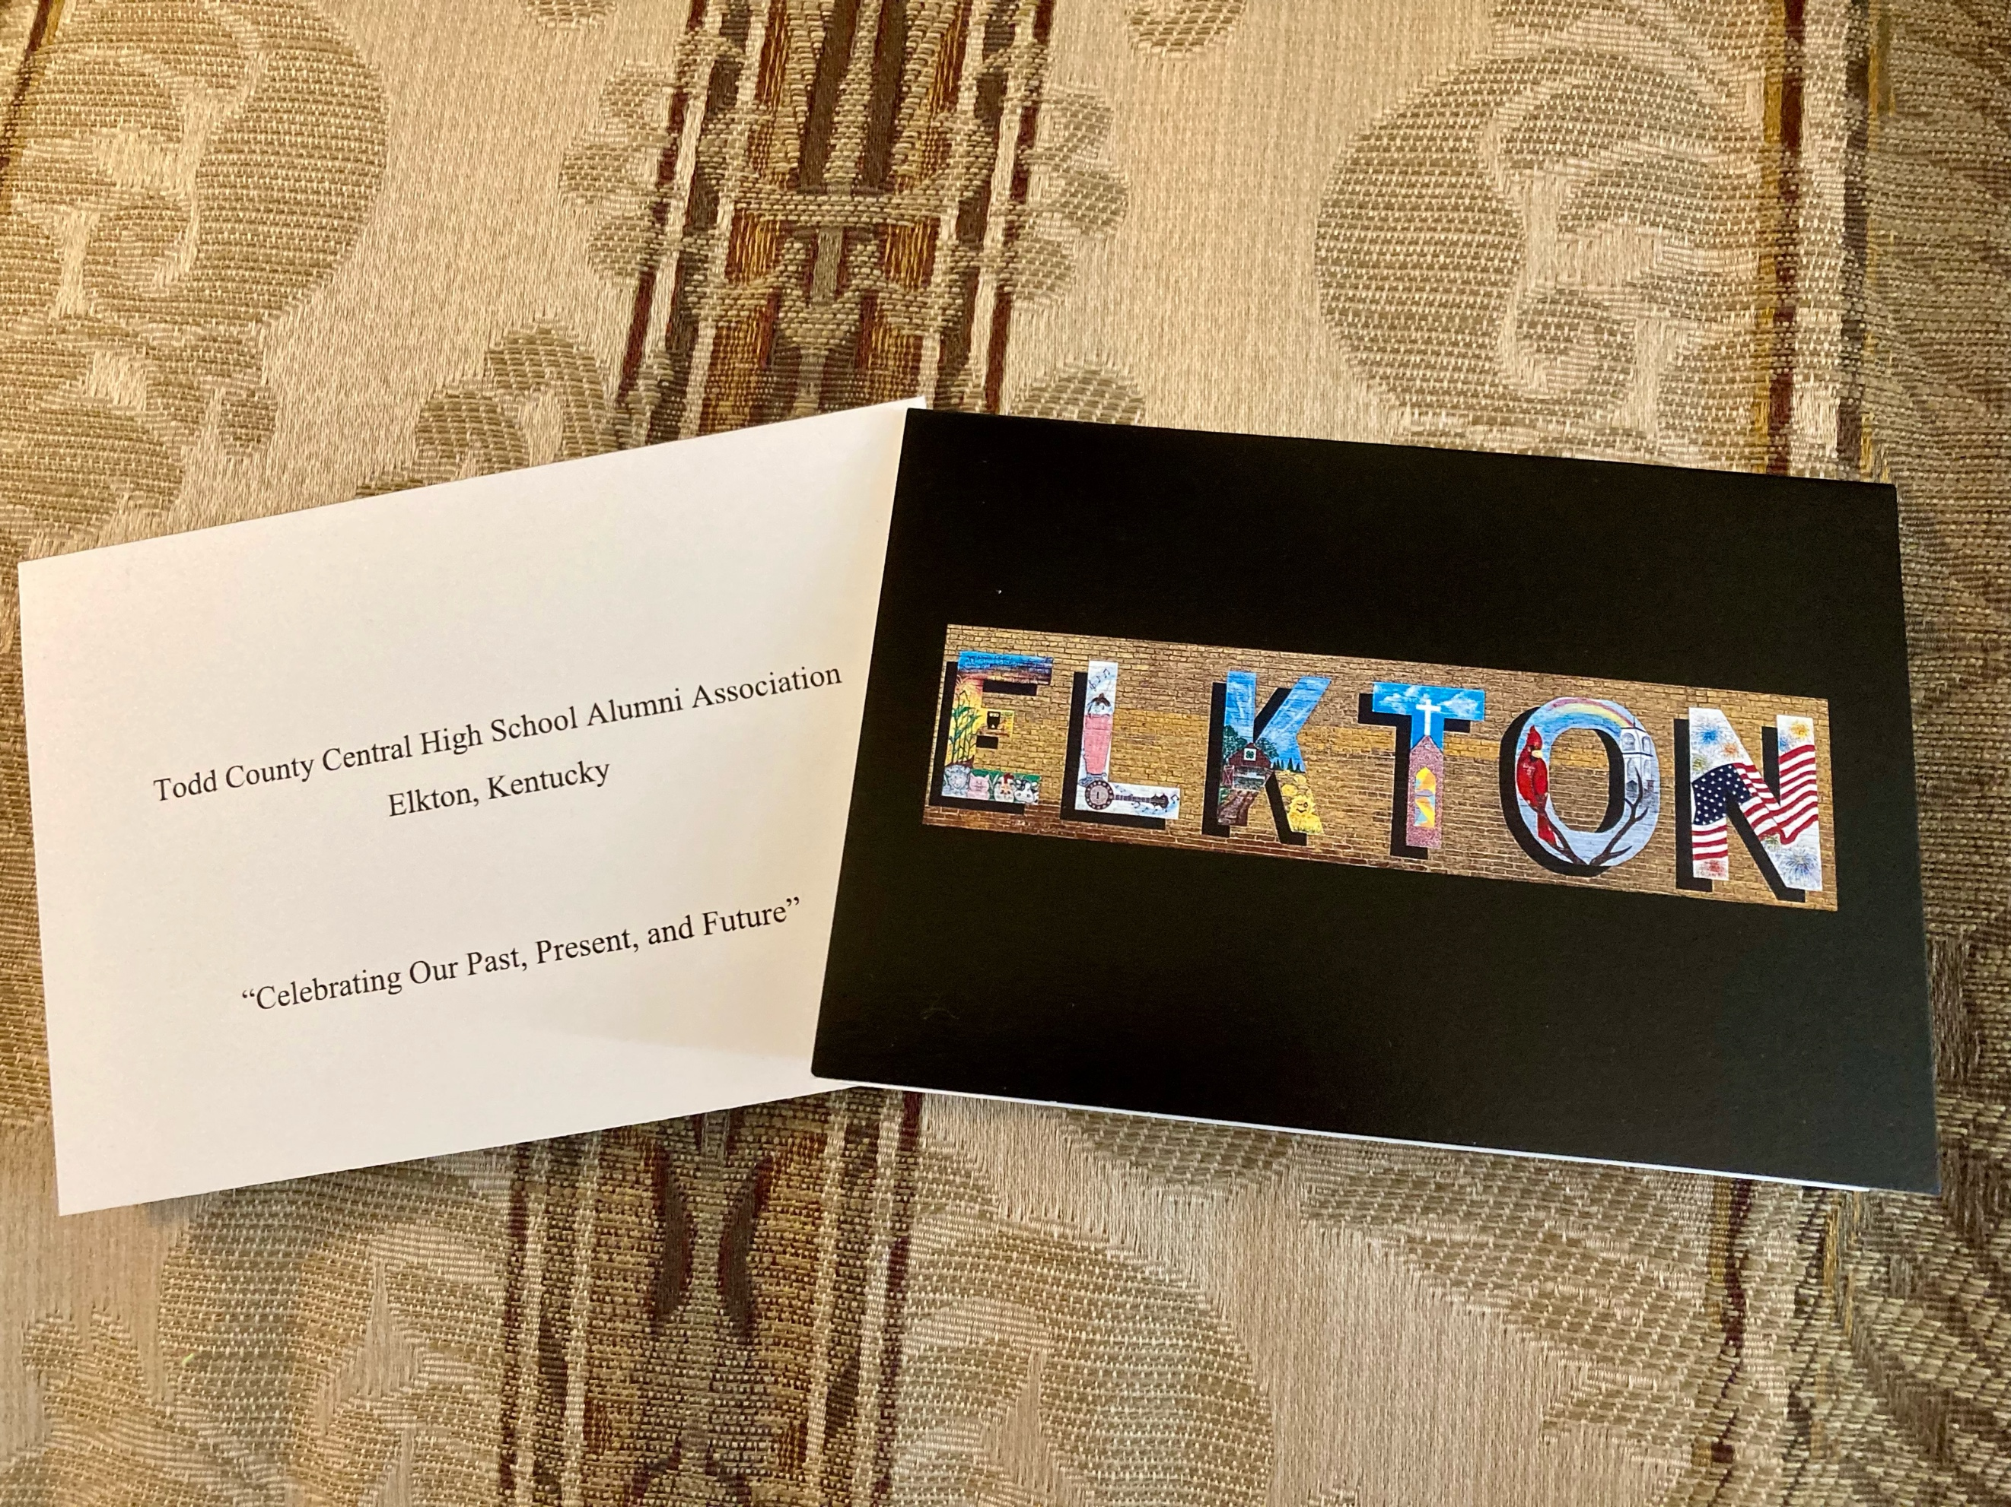

alumni association scholarships tentatively being offered to Graduates of the class of 2024

We ask you share information with our scholarships with all you know. We want the Class of 2024 to be aware of the financial opportunities available to them. The scholarship applications will all soon be available online at our website -- https://tcchs-alumni.org/alumni-scholarships/. Please note that to make the scholarship application process less difficult, those who apply are asked to complete one application and check off the scholarships of interest to them. In order to simplify the process, applicants must make certain to meet all the requirements for each scholarship. The deadline for scholarship applications is April 15, 2024.

- Tom and Rowena Everett Memorial Academic or Technical Scholarship
- Jeffery Wayne Farmer Memorial Scholarship
- Gary Strader Memorial Technical Scholarship
- Todd County Central High School Alumni Association Scholarships (2)
- Todd County Central High School Alumni Association Memorial Academic or Technical Scholarship (This scholarship is in memory of a TCCHS graduate.)
- Howard Ray Stokes Memorial Academic Scholarship
- Albert and Bessie Greenfield Memorial Academic Scholarship
- Todd County Central High School Accounting or Business Scholarship
- Sharon Patterson Shemwell Memorial Scholarship (1st Offered in 2018)
- Todd County Archery Scholarship (Offered Through the TCCHS Alumni Association Beginning in 2019)
- Todd County Chamber of Commerce Academic or Technical Scholarship (1st Offered in 2021)
- “That Guy Who Fixes Stuff” Scholarship
- Carolyn Wells Writing Scholarship (1st Offered in 2018)
- Carolyn L. Wells Academic and Leadership Scholarship (3) (These scholarships will be chosen from those who apply for the other scholarships or from a selection of capable students who demonstrate academic and leadership excellence.)
- Bruce and Linda Marklin Scholarship
- Randall and Nancy Powell Healthcare Scholarships (3) (These scholarships were added first in 2021 and are geared for students pursuing education in the area of healthcare.)
- Novelis-Guthrie Academic or Technical Scholarship (5) (These scholarships were added in late 2021 and are provided by Novelis of Guthrie.)
- TCCHS Alumni Association Technical Scholarship (1) (This scholarship was added late in 2021 by an anonymous donor. It is geared toward a student pursuing a technical career.)
- Jo Ann’s Country Flowers Scholarship (This scholarship was first offered in 2022 by Jo Ann Coblentz, owner of Country Flowers.)
- Myles McIntosh Technical Scholarship

The scholarships below are all new for 2024 graduates.

- Frances Collins Memorial Scholarship – $500.00 Scholarship
- George and Vicki Hall Kennedy Academic or Technical Scholarship – $2000.00 Scholarship
- TCCHS Alumni Foundation Technical Scholarship – $1000.00 Scholarship
- TCCHS Alumni Foundation Technical Scholarship – (Male) – $1000.00 Scholarship
- TCCHS Alumni Foundation Technical Scholarship – (Female) – $1000.00 Scholarship
- TCCHS Alumni Foundation Academic or Technical Scholarship – Must Be a Berea Student – $1000.00 Scholarship
- TCCHS Alumni Foundation Scholarship – Must Be a Student Pursuing a Teaching Degree – $1000.00 Scholarship
- TCCHS Alumni Foundation Technical Scholarship (Male) – $500.00 Scholarship
- TCCHS Alumni Foundation Technical Scholarship (Female) – $500.00 Scholarship
- TCCHS Alumni Foundation Scholarship – $500.00 Scholarship

Two Other Local Scholarship Opportunities Available for the TCCHS Class of 2024

Please note that the Pink Ribbon Network of our area offers a $1000.00 scholarship to a student whose family has had a member battle breast cancer. That family member must be a mother, sister, grandmother, aunt, or immediate family member. Please talk with Mrs. Rachel Westerman about this scholarship opportunity. An essay has to be written for this scholarship.

Also, the local veterans’ organization provides a scholarship opportunity for a senior. If you have questions, please check with Alton Edwards, an active member of the local veterans group.



Have a blessed and safe holiday season 2023 and a blessed 2024!
Todd County Central High School Alumni Foundation Membership Form
Please print and complete one form per member.
The TCCHS Alumni Association / Foundation meets the third Tuesday of each month (excluding December) at 4:00 PM at the Christian Fellowship Center of Elkton Baptist Church. We invite you to attend at any opportunity. We also encourage you to check out our website at https://tcchs-alumni.org/. The newly formed Alumni Foundation has tax-exempt status, thus making donations to our organization tax deductible. We thank you for printing your own membership form(s); that allows us to use our funds wisely.

Alumni’s Name __________________________________________________________________________ Class of ________________

Friend of Alumni Foundation’s Name ________________________________________________________________________________

Maiden Name if Applicable ________________________________________________________________________________________
Mailing Address _________________________________________________________________________________________________
City _______________________________________________________ State Abbreviation _________________ Zip ________________

Home Phone Including Area Code ____________________________________________________________________

Cell Phone Including Area Code ______________________________________________________________________

Personal Email (Please print.) ______________________________________________________________________________

We ask that you assist us by maintaining a current mailing address so that a master spreadsheet of all TCCHS alumni may be maintained. Even if you do not desire membership at this time, please email your current mailing info and your year of graduation (and maiden name if applicable) to tcchsaa@gmail.com. This information will be shared with those planning reunions for different TC classes.

Membership Fees:
- $10.00 Yearly Per Person (Amount Enclosed) __________________________ Check #________________
- $200.00 Lifetime Membership Per Person (Amount Enclosed) __________________________ Check #________________

Scholarship Donation: (Amount Enclosed) __________________________ Check #________________

Please make check payable to TCCHS Alumni Foundation. Thank you.

Please mail to –
Please check as applicable.

______ Renewal of Yearly Membership

______ First-Time Member

TCCHS Alumni Foundation
P. O. Box 611
Elkton, KY 42220

I would like to aid the TCCHS Alumni Foundation by
____ Serving on a committee.
____ Becoming an officer or director.
____ Assisting with an event.
____ Other (Please explain below.)

Cut and Detach Here Please for Your Records

For your records, a receipt for 2015-2016 TCCHS Alumni Foundation Membership:
Date____________________________ Amount _________________ Check #___________

Mailed to or Received by ____________________________________________________________________

Thanks for your support of the TCCHS Alumni Foundation. Please be sure to add a stamp and your mailing address if you use the self-addressed envelope below.

TCCHS Alumni Foundation, Inc.
P. O. Box 611
Elkton, KY 42220

